Project Title: Improving Water Infrastructure at St. Anne’s Middle School, Bingaon, Khunti, Jharkhand

Submitted to:
Anand Bhavan, Arnhem
Netherlands

Submitted by:
RANCHI JESUITS
Ranchi, Jharkhand

PROJECT DETAILS
Project Title | Improving water infrastructure at St. Anne’s Middle School, Bingaon, Khunti, Jharkhand.
Project Location | St. Anne’s Middle School, Bingaon, Block Karra, District Khunti, Jharkhand, India
Name of the Organization | Ranchi Jesuits
Address | SADBHAVNA, Jesuit Provincial’s Residence, Dr. Camil Bulcke Path, P.O. Box 4, Ranchi, JHARKHAND – INDIA.
Responsible person | Fr. George Kerketta, SJ  Sadbhavna, Dr. Camil Bulcke Path, Ranchi – 834 001, India  Tel.: +91-651 2215479  Mobile Phone: +91-9431106878  Email: georgekerkettasj@gmail.com
Project Cost | Rupees 9,49,854 (10,554 €)
Fund Requested | Rupees 900,000 (10,000 €)
Project Duration | Six Months
Date of Submission | 10 October 2024

1. INTRODUCTION
1.1. About the project:
The present project is dedicated to tackling the urgent water crisis at St. Anne's Middle School in Bingaon, Khunti, Jharkhand. The absence of clean water sources poses a grave threat to the health and overall welfare of students and staff. This project's primary objective is the installation of water infrastructure to guarantee a hygienic and supportive learning environment for the entire school community. Through the provision of clean water sources, it aims to alleviate health concerns, enhance well-being, and create an environment where students can thrive academically, free from the burden of water-related challenges.
1.2. About the Implementing Agency-Ranchi Jesuits:
Ranchi was the part of Bengal mission (Calcutta Province) for many years. In 1935 the Ranchi Mission gained an identity of its own, separate from the Calcutta Mission with Fr. Charles Timmerman, as the first Mission Superior. Later it became Vice Province. It became a full-fledged Jesuit Province in 12th March 1956. Now it has become a vibrant province in South Asian Assistancy with more than 382 Jesuits working in India and abroad. It is serving the tribal community by running 2-degree colleges, 1 Management Institution, One Technical Institute, 7 Junior Colleges, 22 high schools, 27 Middle schools and 38 Primary schools in most interior places for Adivasi. Ranchi Jesuit Society is educating 53,915 (2016) through these educational Institutions. It is also running 29 parishes in Ranchi, Assam and Andaman and Nicobar Islands. Some of the schools are attached to these parishes. It has 6 social service centers to cater to the need for socio-economic development of the Adivasi people. The proposed project proposal is for the Munda Tribal children in most backward areas where even the Belgian early missionaries in the 19th century found a tough and unproductive mission field as far as mission activities and results were concerned so abandoned this area for more than 100 years.
Over a period of time, the Ranchi Jesuit Mission has effectively worked towards empowering the educational standard of children in the school belonging to the poor irrespective of caste and creed with limited infrastructure and facilities. Along with that, the Jesuits have carried out various developmental activities such as agriculture, animal husbandry, forestry, etc with the villagers in order to uplift their economic situation. The activities received wide appreciation and support from the communities.
1.3. About the Bingaon Parish:
Bingaon parish was established in 1987 in Khunti district, Jharkhand, near the border with Ranchi district. It falls under Khunti Diocese and is home to 707 Catholic families with a population of 3,535. The parish comprises 35 villages and 12 village chapels/centers. There is an RC Middle School on the church campus with 377 students under the guidance of 8 teachers and 1 priest. Additionally, a boys' hostel accommodates 19 children from remote villages. Mundari and Hindi are the prevalent languages in the parish, which faces challenges in accessing basic facilities and dignified living for tribal populations, especially the Munda tribe. The concentration of tribal population in the parish is very high. The condition of STs and SCs is not very good and they are still struggling for their basic rights and dignified life. They are excluded from the mainstream development paradigm and basic facilities required for dignified life which perpetuate their problems and ultimately their exclusion continued in spite of many efforts.
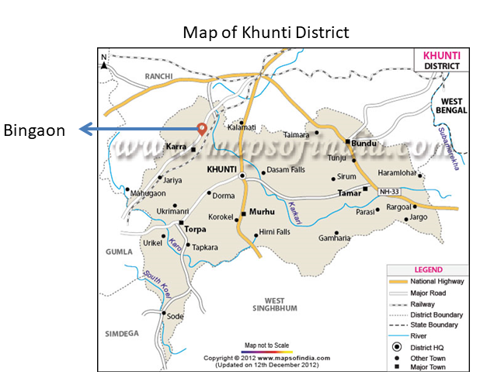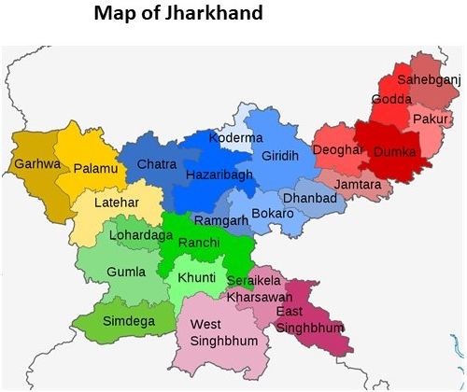
Khunri District
2. PROJECT AREA
2.1 Geography
The project area is located in Karra Block, which is an administrative block in the Khunti district of Jharkhand. The district shares boundaries with West Singhbhoom, Saraikela Kharsawan, Gumla, and Simdega. The climate in the district is subtropical semi-arid, with an annual rainfall of about 1057.12 mm. The area covers 2535 square kilometers, characterized by undulating hills, forests, and diverse soil textures. Forest cover accounts for 35% of the geographical area, comprising very dense, moderately dense, and open forests. This forested land consists of very dense, moderately dense, and open forests, contributing to the region's biodiversity and environmental significance.
2.2. About the people
The Bingaon parish falls under a rural area characterized by its natural surroundings. In this region, the tribal community outnumbers the Muslim and Dalit populations. In the tribal community, Oraon and Munda are the main tribal communities residing in the parish. The majority of the population is Christian in the parish, while a significant number of the population belong to the Sarna religion. The local population mainly falls under the category of Below Poverty Line (BPL). The primary occupations include farming, labor work, semi-skilled labor, fruit, and vegetable vending, as well as running small shops. Due to its proximity to the city of Ranchi, the parish experiences a notable level of migration to the city in search of employment opportunities. Many parents of the parish prefer to enroll their children in government or aided schools, as they find it challenging to afford the expenses associated with education.
2.3. Socio-economic situation of the people
The people of the area depend on rain-fed agriculture for their livelihood. The failure of the monsoon or scanty rainfall directly affects their economic condition. The outdated system of agriculture affects the yield. The area is good for the cultivation of lac but due to marketing and other challenges involved in the production of quality lac the farmers are not able to make the most out of the possibility. The depleted forest too does not provide them with supplementary income. The village markets are in the clutches of the business class who do not give a just price to the home products. Thus, poverty is rampant in the area and the economic condition of the people is deplorable. The government schemes reach them in bits and pieces as the intermediaries pocket most of them. The area has no industry or factory to get labour and therefore many of them go to markets for daily work if available or migrate to cities to earn their livelihood.
2.4 Education
In Bingaon Parish, education is provided through four main schools, with Prabhat Middle School Bingaon and St. Anne's G.T.D.M High School Kachabari being the prominent institutions. However, the region grapples with a concerning dropout rate, with approximately 10% of students leaving school due to financial constraints. This issue underscores the urgent need for targeted interventions to alleviate economic burdens on families, ensuring that children have unhindered access to education. Education support, scholarships, subsidies, and community-driven initiatives could serve as vital tools in combating this challenge and fostering a more conducive learning environment for the youth of Bingaon Parish.

2.5. Health
The people of the Bingaon parish face significant challenges, primarily due to malnutrition, which renders them vulnerable to various diseases. Malnourishment weakens the immune system, making individuals more prone to infections and illnesses. This health issue is further compounded by the fact that the area is prone to malaria. Throughout the year, people in Bingaon are frequently afflicted by malaria, remaining in its grip persistently.
The healthcare infrastructure in Bingaon is limited, with a few primary health centers and private medical practitioners working in the area. Apart from it, there are no major health facilities or hopitals in the parish. As a result, many residents prefer to seek medical attention at hospitals located in nearby areas such as Khunti and Ranchi, where better check-up facilities and more specialized care are available.

3. ABOUT THE SCHOOL
St. Anne's Middle School, located in Bingaon village within a rural area under Bingaon parish, Block Karra, Dist. Khunti, Jharkhand, was established in 1983 by the dedicated St. Anne's sisters. At that time, there were no other educational institutions available in the area to provide schooling for the underprivileged. This pioneering effort aimed to impart quality education and knowledge to those in need, despite numerous challenges like the absence of boundaries, clean water, and restroom facilities. Despite these limitations, the school has persevered. They are also contributing a lot in social and pastoral activities of the parish.

St. Anne's Middle School, under the leadership of Principal Sr. Reshma Regina Tirkey, is a co-educational institution that offers education from Nursery to Class 6, encompassing a total of 11 classes. The school serves a student body of 423, consisting of 238 boys and 185 girls. The students come from diverse backgrounds, with the majority comprising 381 students from Scheduled Tribes (ST), 31 from Scheduled Castes (SC), and 11 from Other Backward Classes (OBC). The school is supported by a dedicated team consisting of 8 teachers and 2 Sisters who work diligently to provide quality education and support to the students.

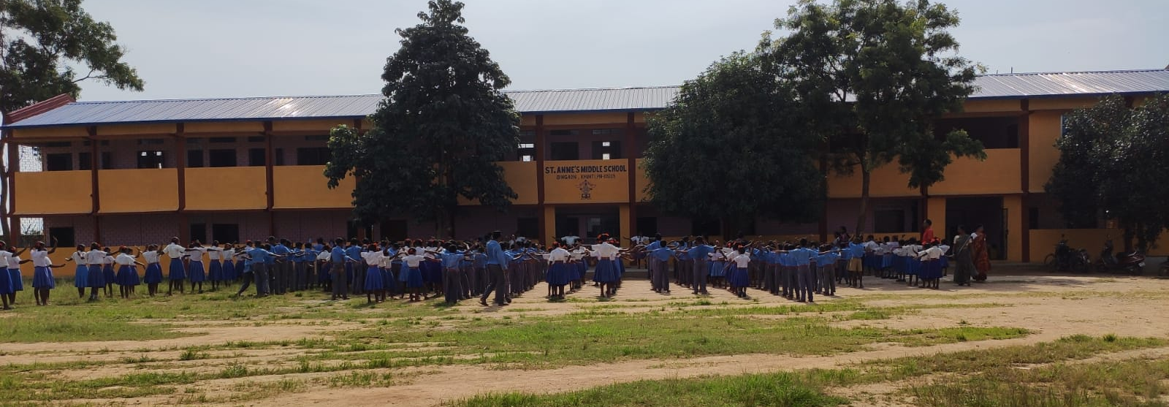

Significance of the school in the area
St. Anne's Middle School in Bingaon plays a crucial role in the lives of local tribal and underprivileged communities. It offers a unique and affordable opportunity for these marginalized groups to access high-quality education, thereby breaking the cycle of poverty and ignorance. With a founding mission to empower the underprivileged, the school not only imparts knowledge but also preserves the rich cultural heritage of tribal communities. It serves as a center for community development, fostering unity and collaboration among families. Despite facing challenges like limited access to clean water, the school significantly contributes to the overall well-being of its students, serving as a symbol of hope and progress for the region's most vulnerable populations. By nurturing future leaders and change-makers, St. Anne's Middle School stands as an essential force in uplifting the Bingaon area, providing quality education that forms a strong foundation for academic and personal success. Its unwavering commitment to education for all, regardless of background, creates a safe and supportive learning environment, shaping the future of the local community while promoting social harmony and positive societal development.

4. PROBLEM STATEMENT
Up until now, the school has been grappling with the persistent challenge of lacking access to clean and safe drinking water, despite making gradual progress in managing other essential needs. Each year, a substantial number of students seek admission to our school, but the absence of proper water facilities proves to be a significant hurdle. Despite completing the school's boundary and actively working on restroom facilities, ongoing financial constraints hinder us from addressing this critical need for clean water.
Regarding the current water situation, the primary sources for drinking water are a well and a hand pump, both of which heavily rely on rainwater. During the summer season, these sources dry up, creating additional difficulties. Even during rainy periods, the water often becomes contaminated and unusable. Consequently, students resort to carrying water bottles, which unfortunately are often insufficient for their needs.
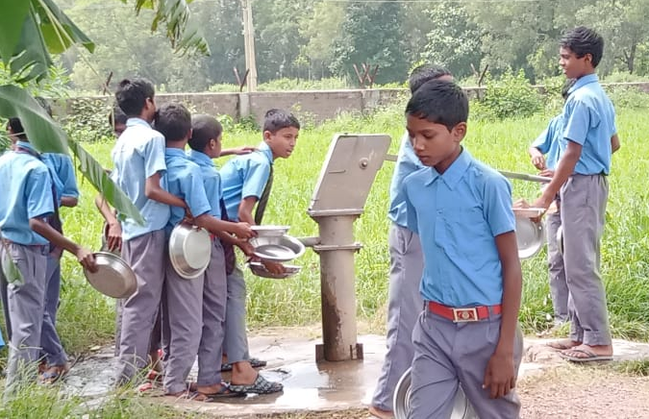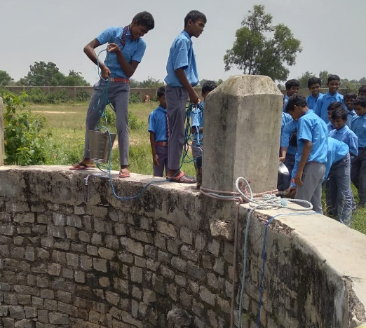
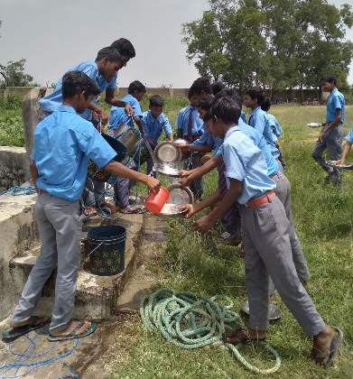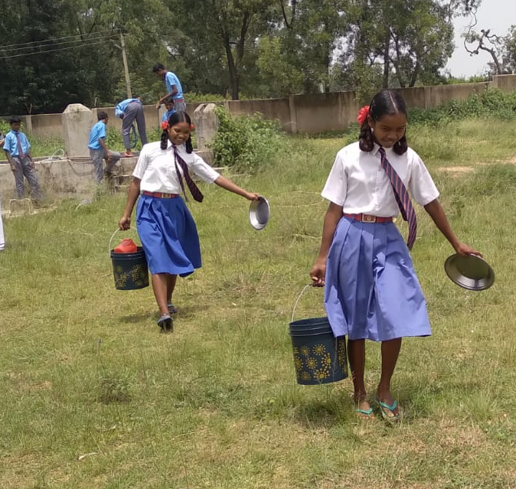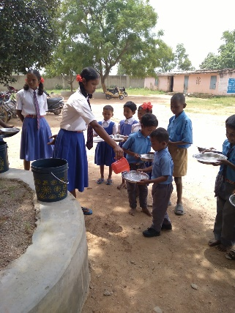

Furthermore, the existing water quality poses serious health and hygiene concerns for the children. Consuming dirty water leads to recurrent illnesses, including fevers, stomachaches, and cases of dysentery. Compounding the issue, the parish lacks a major health facility or hospital to provide adequate medical attention.
The educational pursuits of the students are significantly impacted by the water situation. Illnesses resulting from contaminated water lead to frequent absences from class. As a result, students struggle to keep up with the curriculum, leading to feelings of inadequacy and inferiority among them.
Hence, the proposed project would like to provide water facilities for children in the school.
5. PROJECT OBJECTIVES
The key objectives of the project are as follows,
- To drill a 700-foot deep borewell and install a PVC casing to ensure a reliable supply of clean drinking water while preventing contamination.
- To set up two 2000-liter overhead tanks, lay necessary pipes, and install drinking water taps to facilitate the distribution of safe water for drinking, cooking, and sanitation throughout the school.
- To install a solar submersible pump and necessary electrical components to create an eco-friendly and efficient water pumping system that operates independently of unreliable electricity supply.
- To install a high-capacity water filter and dispensers to provide safe drinking water for students and staff, promoting better health and hygiene within the school environment.

6. ACTIVITIES
The proposed project will have the following activities,
- Drilling a Deep Borewell – 700 feet: A professional borewell drilling company will be contracted to drill a borewell to a depth of 700 feet. The depth is determined based on hydrological studies to ensure access to a sustainable aquifer. The drilling process will involve geological surveys, drilling operations, and sealing the well to prevent contamination.
- Installing a PVC Basin – 110 feet: A 110-feet PVC casing pipe will be installed in the borewell. The casing will prevent soil and debris from entering the borewell, ensuring clean water is pumped out. It will also extend the lifespan of the borewell by providing structural support.
- Procuring and Installing Accessories (Electrical Wires, PVC Pipe, Rope for Borewell Fittings): The required accessories will be procured, including electrical wires to power the submersible pump, PVC pipes for water conveyance, and rope for lowering and securing the pump inside the borewell. A technician will be hired to install these components in coordination with the borewell drilling team.
- Installing Solar Submersible Machine, Electric Cable, and Solar Panel: A solar-powered submersible pump will be installed inside the borewell to pump water to the overhead tanks. A solar panel system will be set up to provide power to the pump, ensuring it operates efficiently even in situations with poor electricity supply. This will be followed by the installation of electric cables to connect the solar system to the pump.
- Setting up Two Overhead Water Tanks (2000 Liters Each): Two overhead tanks, each with a capacity of 2000 liters, will be installed on a high platform. The tanks will be connected to the solar-powered pump system to fill them with water from the borewell. The tanks will store water for drinking, cooking, and sanitation purposes.
- Completing Civil Work (Fittings, Transportation, and Other Infrastructure): Civil works will include constructing the overhead tank platform, trenches for laying pipes, and protective housing for the pump and control systems. Transport of materials and on-site installations will be handled by contractors specialized in civil engineering and plumbing.
- Laying Roll Pipe from Borewell to Overhead Tanks (1,200 feet): 1,200 feet of high-quality roll pipe will be laid underground, connecting the borewell to the overhead tanks. The pipe will be carefully routed and buried to prevent damage and ensure reliable water flow. Skilled technicians will handle the installation to minimize leaks and ensure durability.
- Laying Roll Pipe from Overhead Tanks to Midday Kitchen and Drinking Water Points: Additional pipes will be laid to supply water from the overhead tanks to the school’s kitchen and designated drinking water stations. This will ensure a steady supply of water for cooking and drinking, improving the overall health and hygiene of the students.
- Installing Drinking Water Taps with Brickwork Stand and Fixing Tiles: Drinking water taps will be installed at multiple points around the school, supported by sturdy brickwork stands. The stands will be tiled to make them easy to clean and maintain, ensuring that students have easy access to safe drinking water throughout the day.
- Establishing a Running Water Facility with Taps in the Toilet Block: Water pipes will be connected from the overhead tanks to the school’s toilet block, with taps installed for handwashing and flushing. This will help maintain cleanliness and reduce the spread of diseases, improving overall hygiene in the school.
- Installing a Water Filter: A high-capacity water filter machine will be installed to purify the water drawn from the borewell, removing contaminants and ensuring it is safe and clean for student use. This will provide all students with access to safe drinking water.
- Providing a Water Dispenser: A water dispenser will be set up in high-traffic areas such as classrooms or the school entrance, allowing students to easily refill their bottles or drink directly from the dispenser. This will encourage students to stay hydrated throughout the day.
- Installing RO Water Filter for school staff: A smaller water filter will be installed near the staffroom for use by the principal, teachers, staff, and guests, ensuring they have access to clean and safe drinking water throughout the day.

7. RESULTS
- Installation of a deep borewell, solar water pumps, filters, and overhead water tanks provides consistent access to clean drinking water for students and staff at St. Anne’s Middle School, Bingaon.
- Reduction in waterborne diseases among students due to the provision of clean water and improved sanitation facilities.
- Higher attendance rates as students experience fewer illnesses, allowing them to engage consistently in their studies.
8. OUTPUTS
- Completion of installing one borewell, PVC casing, and installation of two overhead water tanks (2000 liters each) and solar water pump.
- Laying of 1,200 feet of piping for water distribution to the school’s kitchen, drinking points, and toilet facilities completed.
- A high-capacity water filter machine was installed to ensure the purity of drinking water.
- Provision of small water filters for staff use and a water dispenser for easy access.
- Running water facilities installed in the toilet block, promoting handwashing and sanitation practices.
- Clean running water accessible throughout the school premises.
9. OUTCOMES
- The installation of a deep borewell will ensure a reliable and continuous supply of clean and safe water at the school. Students and staff will no longer have to rely on the iron-rich water from the dysfunctional hand pump or fetch water in buckets from distant sources. This will significantly improve their access to clean water for drinking, cooking midday meals, and maintaining proper hygiene.
- With access to clean water, the health and well-being of the students and staff at St. Annes’s Middle school will witness a marked improvement. Consumption of safe drinking water will reduce the risk of waterborne diseases and illnesses caused by contaminated water, leading to healthier students and a more conducive learning environment.
- Significant decrease in the prevalence of waterborne diseases and associated absenteeism, leading to better overall health among students.
- Access to clean water and functional sanitation facilities will foster better hygiene practices among the students. They will have the means to wash their hands regularly, promoting good hygiene habits and reducing the risk of communicable diseases.
- The project's success will alleviate the burden on students and staff, who previously had to carry water in buckets from distant sources. This will save valuable time and energy, allowing them to focus more on their studies and other productive activities.
10. IMPACTS:
The project is expected to have significant long-term impacts on the school. By ensuring access to clean water, it will lead to sustained improvements in health outcomes among students, resulting in enhanced quality of life and productivity. The educational environment will be notably enriched as students experience fewer health-related absences, leading to improved literacy and academic achievements. This, in turn, will contribute to a reduction in poverty levels, as families benefit from better education and health. Furthermore, the success of this initiative will position St. Anne's Middle School Bingaon as a model for other schools in the region, inspiring similar projects that address basic infrastructure needs and promote overall community health and well-being. Ultimately, this project will strengthen community resilience and foster socio-economic development, creating a more empowered and healthier population.
11. PROJECT TIMELINE
Depending on the approval of the project and the availability of funds, the project will be completed in 6 months. Final reporting to the donor will be done in the 7th month of the project.
Work Plan | Months
Work Plan | 1 | 2 | 3 | 4 | 5 | 6
Finalize contracts and agreements with the contractor/agents.
Drilling a Deep Borewell – 700 feet
Installing a PVC Basin – 110 feet
Procuring and Installing Accessories (Electrical Wires, PVC Pipe)
Installing Solar Submersible Machine, Electric Cable, and Solar Panel
Setting up Two Overhead Water Tanks (2000 Liters Each)
Completing Civil Work (Fittings, Transportation, and Other)
Laying Roll Pipe from Borewell to Overhead Tanks (1,200 feet)
Laying Roll Pipe from Overhead Tanks to Kitchen and Drinking Points
Installing Drinking Water Taps
Establishing a Running Water Facility in Toilet Block
Installing a Water Filter
Providing a Water Dispenser
Installing Small Water Filters for Staff

12. MONITORING, EVALUATION AND REPORTING AND FOLLOW-UP PLANS
- By School Headmistress: The headmistress will be responsible for overseeing the day-to-day constriction activities and ensuring that the work is carried out in accordance with the plan. monitoring of the project supported by the teachers of the school. She will work closely with the contractors to ensure that the materials used are of high quality and that the work is completed on time.
- Fr. George Kerketta SJ., Province Development Director on the other hand, will be fully responsible for overseeing the quality of work and financial aspects of the project and the overall progress of the project. He will be responsible to prepare the progress report, final report, and financial report of the project; and updating the donors as per the timeline.

- ESTIMATED BUDGET:
S.N. | Particular | Per unit cost | Amount in INR | Amount in €
1 | Drilling deep bore well – 700 feet deep | 135 per feet | 94,500 | 1,050
2 | Providing PVC basin- 110 feet | 650 per feet | 71,500 | 794
3 | Accessories - Electrical wires, PVC pipe, rope for fitting inside the bore well | LS | 75,000 | 833
4 | Solar submersible machine, electric cable & Solar panel- | 215,000 per set | 210,000 | 2,333
5 | 2 overhead tanks of 2000 liters | 12,500 | 25,000 | 278
6 | Civil work for fittings, transportation, and others | LS | 10,000 | 111
7 | Roll pipe from deep bore well to the overhead tank – 1,200 feet | 15 per feet | 18,000 | 200
8 | Roll pipe from tank to midday kitchen shade and drinking water | LS | 12,000 | 133
9 | Drinking water taps with brickwork stand and fixing tiles | LS | 2,70,000 | 3,000
10 | Running water facility with taps in the toilet block | LS | 50,000 | 556
11 | Water filter |  | 67,024 | 745
12 | Water dispenser |  | 15,000 | 167
13 | R. O. Water purifier Machine |  | 21,830 | 243
14 | Installation of Nos 11,12 &13 |  | 10,000 | 111
 | Total |  | 9,49,854 | 10,554
Currency conversion: @ 1 € = 90 INR

Fr. Geroge Kerketta SJ.
Province Development Director
Ranchi Jesuits

